1. Purpose
This Python application analyzes production data stored in a Microsoft SQL Server database and identifies stable production runs for each unique combination of:
- Prog_Nr – production program number
- ordername – production order name
The detected production runs are stored in a dedicated result table: LinePC7442.dbo.Ex2_stableProd_dev
The application is designed for incremental processing. A Prog_Nr + ordername combination that already exists in the result table is considered processed and is skipped during subsequent executions.
The analysis starts with production data from: 2025-01-01
The main execution function is: run_latest_analysis()
Database Configuration:
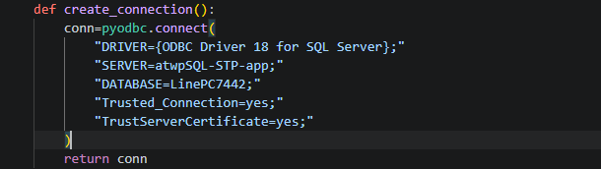

Connection parameters
Parameter | Value
Server | atwpSQL-STP-app
Database | LinePC7442
Driver | ODBC Driver 18 for SQL Server
Authentication | Windows / Trusted Connection
Certificate validation | Trust server certificate
The application accesses two principal database tables.
Source table: LinePC7442.dbo.DI_Ex2_Istwerte
This table contains the production measurement data.
Result table: LinePC7442.dbo.Ex2_stableProd_dev
This table stores the identified stable production runs and combinations for which no valid production run was found.

Start Create SQL connection Find Prog_Nr + ordername combinations Filter out combinations already in result table For each new combination Valid segments foundCommit transactionClose
| |
+ Load production measurements + Calculate stable production periods
| |
+ No data? Insert invalid results +Calculate production meters
| |
+ Analyze production data +Assign production run numbers
| |
+ No valid segment? Insert invalid +Insert results
results
Source Date :
The application uses the following start date: SOURCE_START_DATE = "2025-01-01"
All production data analyzed by the application must have a timestamp on or after this date.
This affects both:
- discovery of new program/order combinations
- loading of production measurements
Database connection:
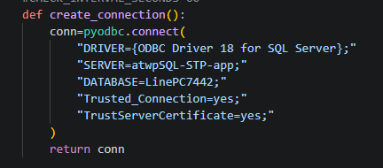
Purpose :
Creates a connection between Python and the SQL Server database.
Connection details:
SQL Server: atwpSQL-STP-app
Database: LinePC7442
Driver: ODBC Driver 18 for SQL Server
Authentication: Windows/Trusted Connection
Certificate: Server certificate is trusted

Output
The function returns a pyodbc database connection object.
This connection is subsequently passed to the other functions.
clear_stable_production_table() : Clearing the result table
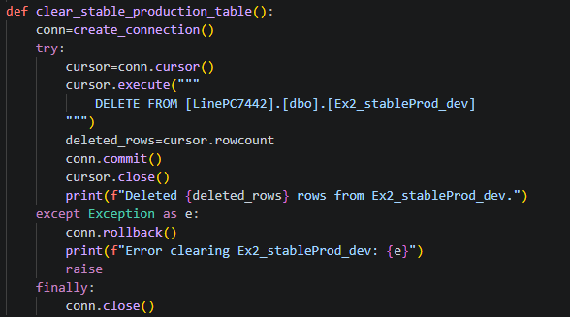
Deletes all existing records from: Ex2_stableProd_dev
The function is intended mainly for resetting the development/result table before complete reprocessing.
Important safety feature: If the deletion fails: conn.rollback() is executed.
Therefore, the transaction is not left in an incomplete state.
Note : In the current program this function is commented out: clear_stable_production_table() , So it is not executed during normal operation.
target_table_is_empty () : Checking whether the target table is empty
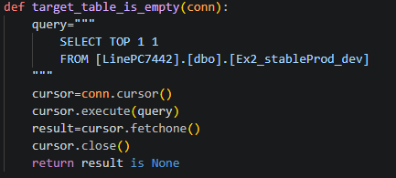
Purpose : Check whether Ex2_stableProd_dev contains at least one record. Instead of loading the complete table, it uses: SELECT TOP 1 1, This makes the check efficient.
Return value : True → table is empty
False → table contains at least one row
Current usage : This function is currently defined but is not called by the active execution path.
get_latest_target_timestamp() : Getting the latest target timestamp
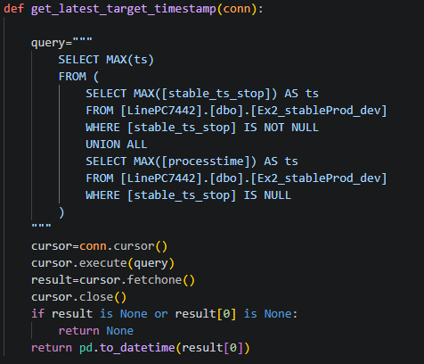
Purpose
Determines the newest timestamp already stored in the result table.
There are two possible timestamp sources:
Valid production run -> stable_ts_stop
Invalid result -> processtime
The function calculates the maximum timestamp from both categories.
Return: A Pandas timestamp is returned: pd.to_datetime(result [0])
If there is no time stamp: None
Current usage: This function is currently not used by the active incremental workflow.
combination_exists(): Checking an existing Program/Order combination
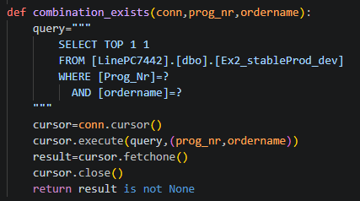
Purpose
Check whether a particular combination already exists in the target table.
The combination consists of: Prog_Nr+ordername
The SQL query uses parameters:
cursor.execute(query,(prog_nr,ordername))
This is preferable to directly inserting Python values into the SQL statement.
Result: True → combination already exists
False → combination does not exist
This function is important because it prevents an already processed order from being processed again.
get_program_orders_full () : Reading all Program/Order combinations
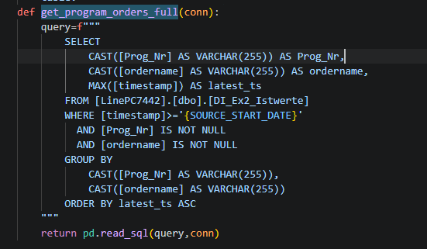
Purpose: Retrieves all unique: Prog_Nr + ordername combinations from the source table: DI_Ex2_Istwerte
For every combination, it also determines: MAX (timestamp)
which represents the latest available source timestamp.
Filtering Only data after:SOURCE_START_DATE is considered.
Null program numbers and order names are excluded.
Output: A Pandas DataFrame containing: Prog_Nr, ordername, latest_ts
Current usage
This function is available for a full data overview but is not used in active incremental execution.
get_new_program_orders () : Finding new orders , This is one of the main functions of the incremental analysis.
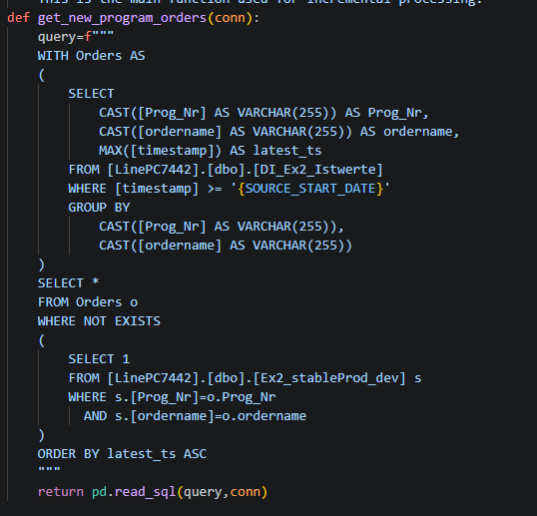
Purpose: It identifies combinations that exist in the source table but do not yet exist in the result table.

Conceptually:
DI_Ex2_Istwerte Prog_Nr + ordername already in result?
│ │
│ ├- YES → Ignore
│ │
│ └── NO
▼
New order
SQL logic :
The function first creates a list of source combinations: WITH Orders AS (...)
Then it uses: WHERE NOT EXISTS
to remove combinations that are already present in Ex2_stableProd_dev.
Result : A DataFrame containing new orders sorted by: latest_ts ASC
This means older/newly discovered orders are processed first according to their latest source timestamp.
get_existing_production_runs() : Existing production runs
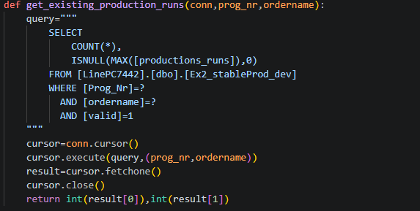
Purpose: Determines whether valid production runs already exist for a particular Program/Order combination.
It returns two values: existing_count
existing_max_run

For example: existing_count = 3
existing_max_run = 3
means three valid production runs have already been stored, with run number 3 being the highest.
SQL condition: Only records with valid = 1are counted.
get_production_data() : Loading production measurements. This is one of the most important data-processing functions.
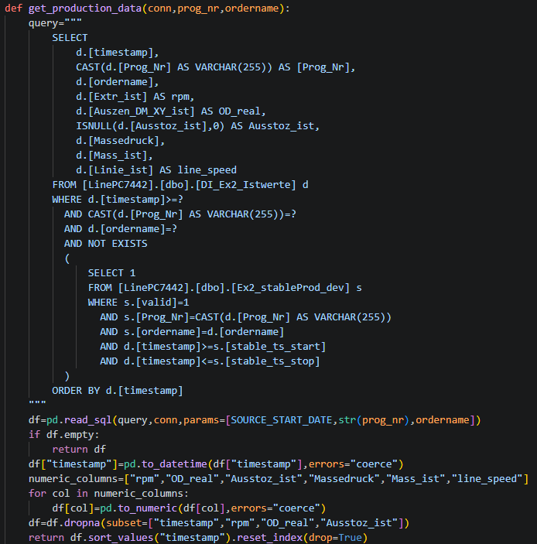
Purpose: Loads measurement data for one:Prog_Nr + ordernamecombination.
The source is: DI_Ex2_Istwerte Selected production variables

The SQL query loads:
Source column | Python column
timestamp | timestamp
Prog_Nr | Prog_Nr
ordername | ordername
Extr_ist | rpm
Auszen_DM_XY_ist | OD_real
Ausstoz_ist | Ausstoz_ist
Massedruck | Massedruck
Mass_ist | Mass_ist
Linie_ist | line_speed

Important logic: The query contains: NOT EXISTS to exclude data that already belongs to an existing valid production run.
This prevents previously processed production periods from being analyzed again.
Data cleaning
The function converts: timestamp to Pandas datetime.
Numeric production columns are converted using: pd.to_numeric(..., errors="coerce")
Rows with missing critical values are removed.
Critical values are timestamp, rpm, OD_real, Ausstoz_ist
find_production_segments() : Detecting stable production segments. This is the core production-analysis function.
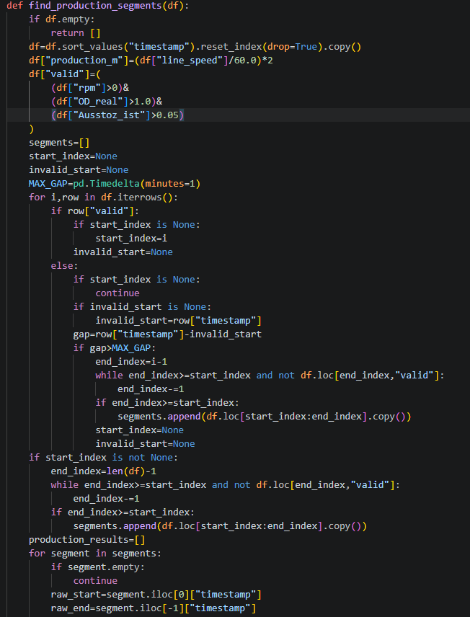
Purpose: Determines when the machine is producing continuously under the defined production conditions.
First, production meters are calculated: df["production_m"]=(df["line_speed"]/60.0)*2
Then each measurement is classified as valid or invalid.
Current production-validity criteria:
A row is considered valid when:
rpm > 0
OD_real > 1.0
Ausstoz_ist > 0.05
So: RPM must be positive AND OD must be greater than 1.0 AND Ausstoss must be greater than 0.05
Segment detection: The algorithm goes through the measurements chronologically.
When valid data begins: start_index is stored.
When invalid data appears, the algorithm checks how long the invalid period lasts.
The maximum allowed gap is: MAX_GAP=pd.Timedelta(minutes=1)
Therefore, an invalid interruption of up to one minute does not immediately terminate the production segment.
Simplified example
Valid Valid Valid Valid 30 sec invalid Valid Valid Valid Valid
This can remain one production segment.
But: Valid Valid Valid 2 min invalid Valid Valid
causes the previous segment to end.
First production run — 9-minute exclusion
First-run stabilization logic
For the first production segment, the code intentionally ignores the first nine minutes.
if len(production_results)==0:
ignore_time=raw_start+pd.Timedelta(minutes=9)
Then:
stable_start=after_start.iloc[0]["timestamp"] is selected
Purpose: This appears to represent a stabilization/ramp-up period at the beginning of production.
Conceptually:
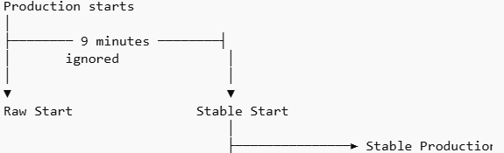
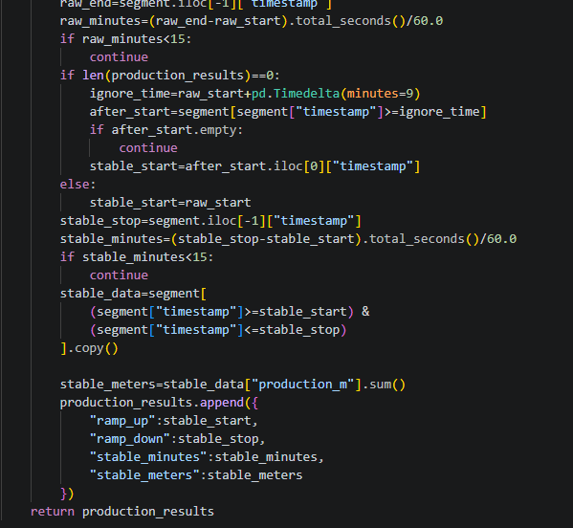
Minimum production duration: Minimum duration validation
The raw segment must be at least: 15 minutes otherwise continue is executed.
The stable portion must also be at least: 15 minutes
Therefore, a segment must satisfy the duration requirements before it is stored as a production run.
Stable meters calculation: Production-meter calculation
The function calculates: stable_meters=stable_data["production_m"].sum()
where:
production_m=(line_speed/60.0)*2
Therefore, the application calculates a production distance from the line speed and accumulates it over the stable production period.
The result returned for each segment contains:
{"ramp_up": stable_start,
"ramp_down": stable_stop,
"stable_minutes": stable_minutes,
"stable_meters": stable_meters
}
get_next_run_number(): Determining the next production run number
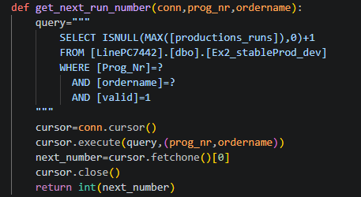
Purpose: Determines the next available production-run number.
The SQL logic is: MAX (productions_runs) + 1
for the specified Program/Order.
Example:
Existing:
Run 1
Run 2
Run 3
Next:
Run 4
If no valid production run exists: MAX = 0 therefore: next run = 1
insert_production_run(): Writing a valid production run
Purpose:
Stores a detected stable production run in: Ex2_stableProd_dev
Stored information
The function inserts: Prog_Nr, ordername, stable_ts_start, stable_ts_stop, productions_runs, valid, processtime, prodRun_time, stable_meters
The record is marked: valid = 1
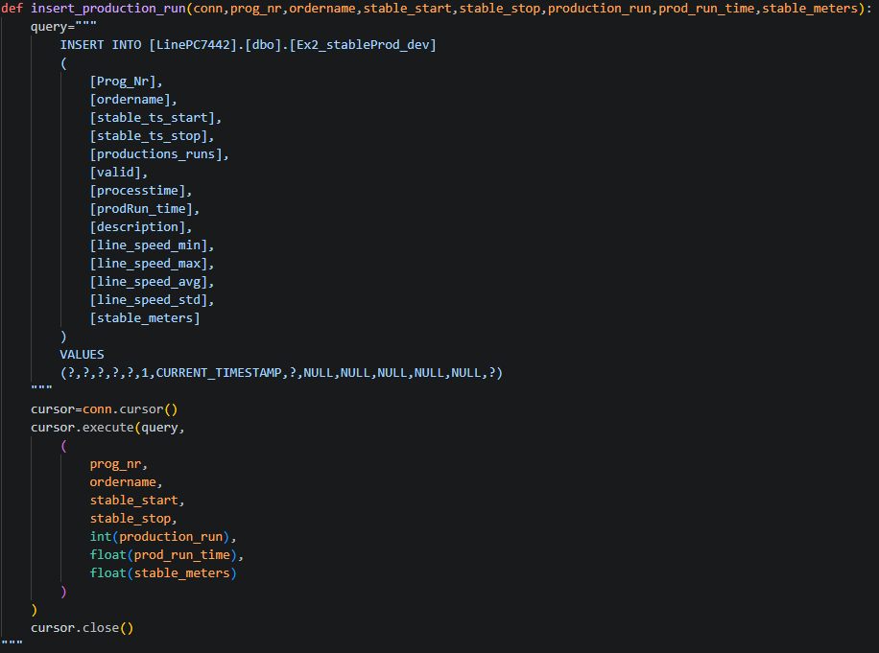
Currently empty fields: The following values are currently inserted as NULL:
description
line_speed_min
line_speed_max
line_speed_avg
line_speed_std
These could be calculated in a future extension.

insert_invalid_result(): Storing an invalid result
Purpose: If no valid production run is found, the application stores an invalid result.
The record contains:
valid = 0
productions_runs = 0
prodRun_time = 0
Duplicate protection: Before inserting, the function checks: IF NOT EXISTS
for the same: Prog_Nr + ordername
Therefore, it does not create multiple invalid records for the same combination.
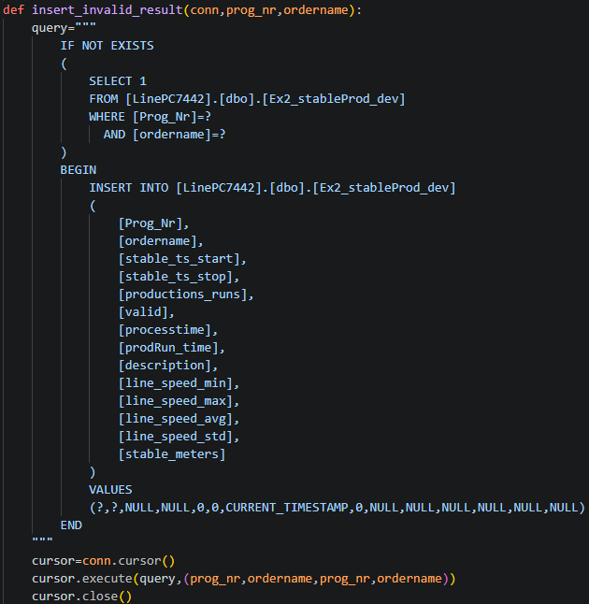
process_program_order(): Main processing function
This function coordinates the processing of one Program/Order combination.
Important point:
This function is effectively the controller for processing one order.
It combines the data retrieval, analysis and database-writing functions.

Processing sequence:
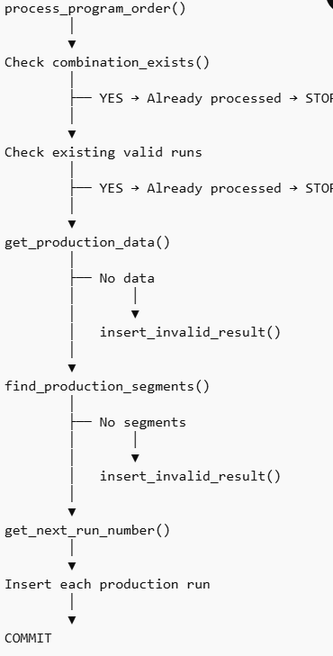
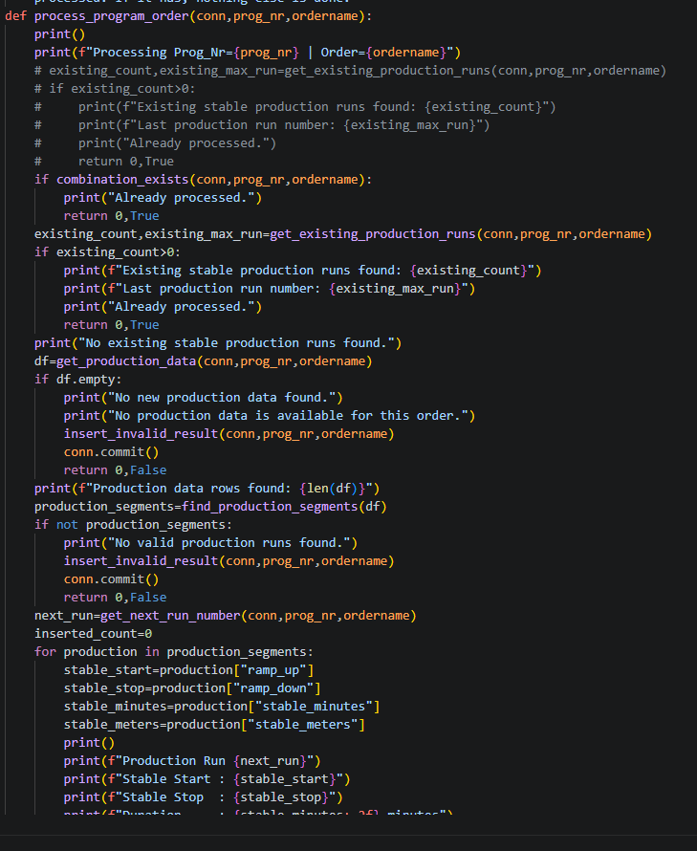
run_latest_analysis(): Incremental analysis controller
This is the main function executed by the program.
It starts with: program_orders=get_new_program_orders(conn)
Step 1 — Find new orders
The function asks the database:
Which Program/Order combinations are present in the source data but not yet in the result table?
Step 2 — Process every new order
For each returned row: process_program_order(conn,prog_nr,ordername) is called.
Step 3 — Collect statistics
The program counts: New orders processed
Total production runs inserted
Step 4 — Commit/rollback
Successful database operations are committed.
If an exception occurs: conn.rollback() is executed.
Finally: conn.close()
closes the database connection.
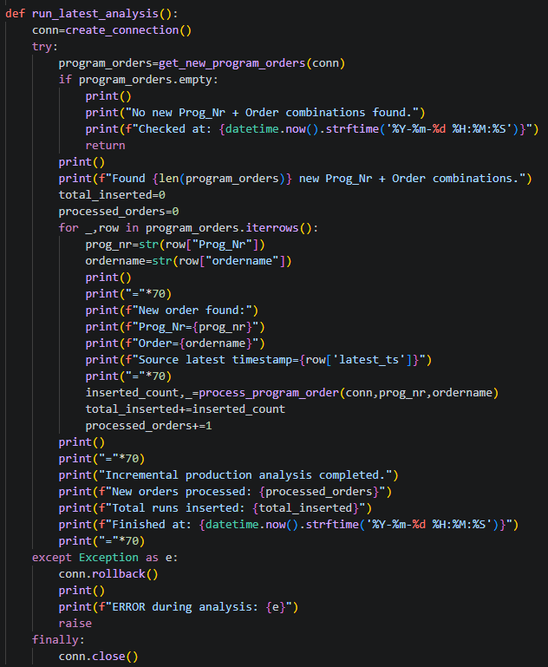
Main Program:
Program entry point
if __name__=="__main__":
#clear_stable_production_table()
#run_automated_analysis()
run_latest_analysis()
When the Python file is executed directly, it calls:
run_latest_analysis()
The table-clearing and automated-analysis functions are currently disabled.
Complete Application Flow :
